Notes:

1. The project code is built using Visual Studio 2013 Express for web. Please use a compatible IDE for browsing the code.
2. The images below show (Fig 1, 2, 3 and 4) the UI of the project and the most important parts of the code (Fig 5 and 6):
   1. There are 4 main controllers:
      1. ShoppingCategoryListController – Look at the Get method this returns all the categories and products JSON via Rest API. Initially all the categories and the shopping items under each categories are stored in the DB (again template DB scaffolded using EntityFramework and Package Manager). The data can be used as it is, or can be constructed using the SQL scripts provided. (See Fig 7 for db).
      2. ShoppingItemController – None of these items are being used in the project, result of scaffolding.
      3. CheckoutItemController - Again scaffolded code
      4. CheckoutListController – The main method to Post back all the basket items back to the server. Until they are posted back to the server, the items are stored in a cookie (to avoid round trips for each “Buy” action). Once the user posts back, the posted data is not stored in the DB, it is just processed and returned back (the data is more filled up, DTOs are filled up with product names, calculations, etc). A user can buy an item more than once and the total is shown on the checkout page.
   2. View binding is done using Knockoutjs
3. To run the project, login using vinay/vinay123 (first signup as vinay/vinay123) for a simple demo (database will show up with some sample data).
4. There is one change in the implementation, the checkout page is not a separate page, but ajax loads a different checkout page on the same page.

Fig 1: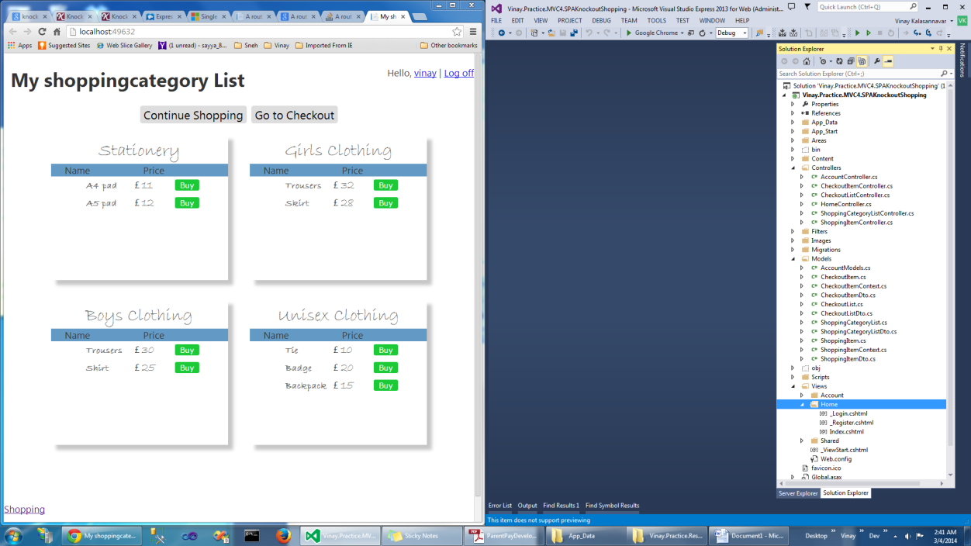 Fig 2: 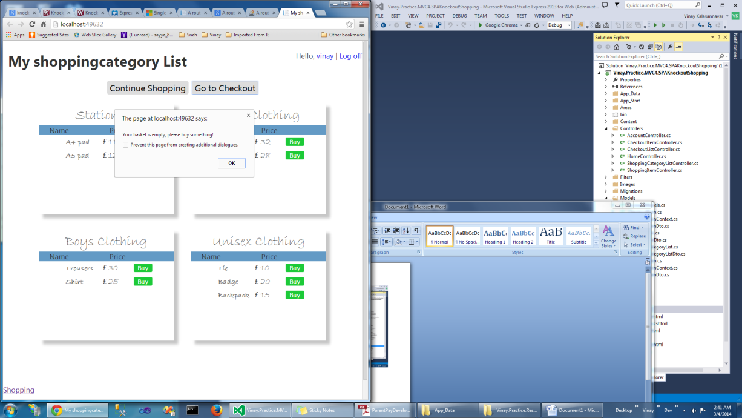

Fig 3: 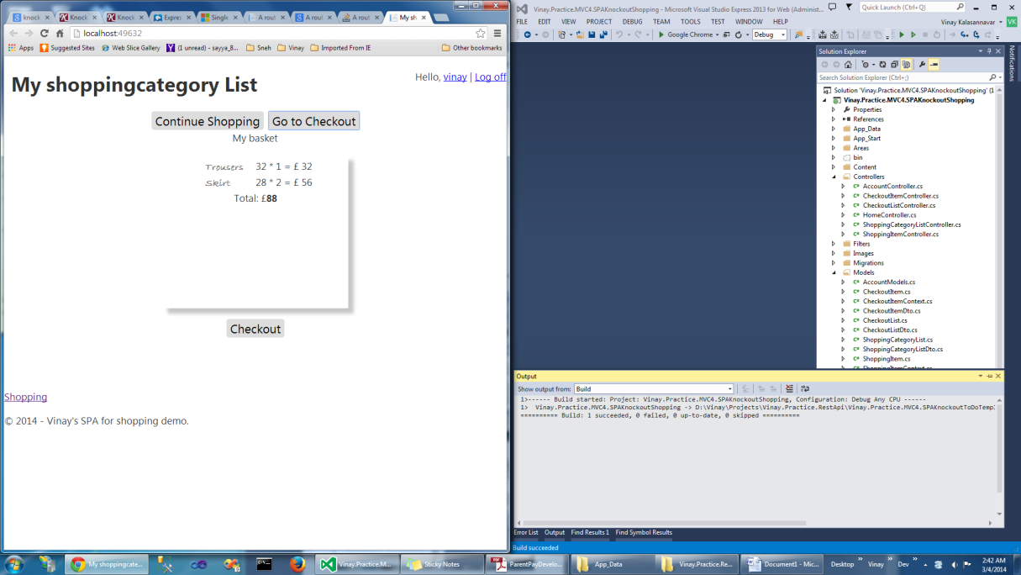 Fig 4: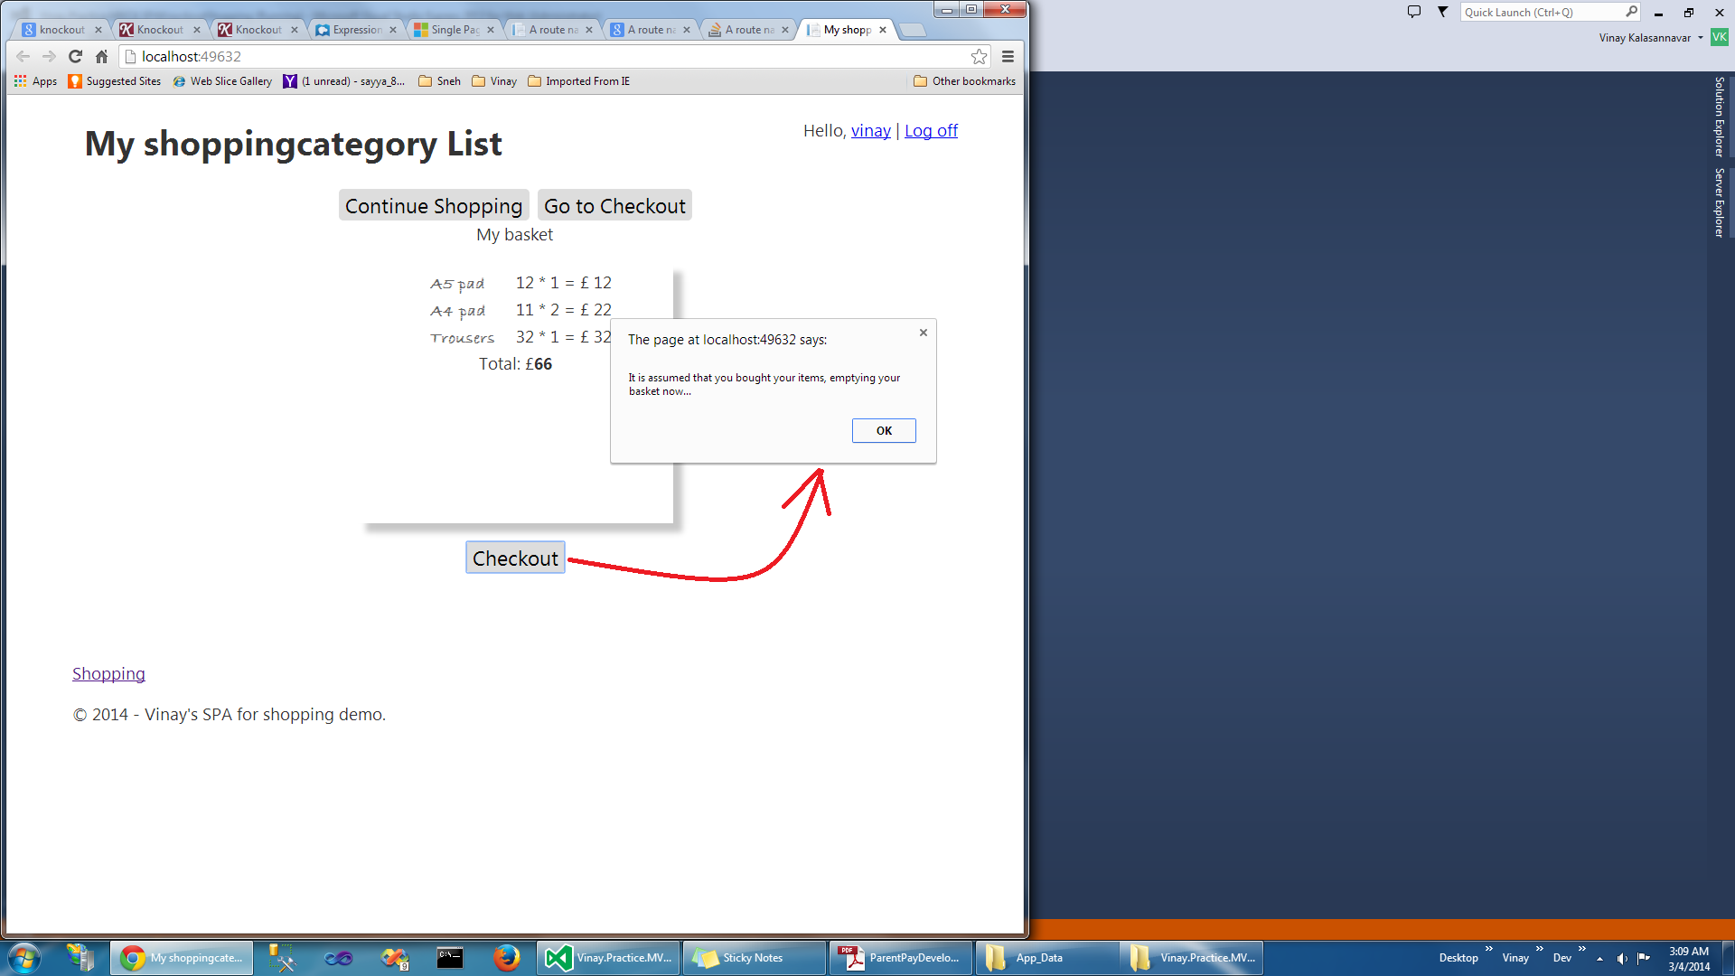

Fig 5: 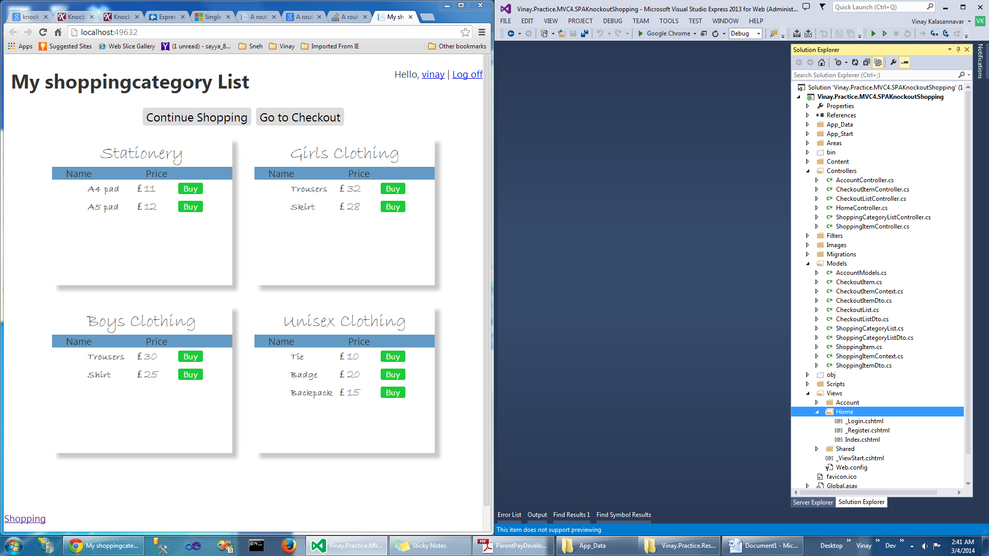 Fig 6: 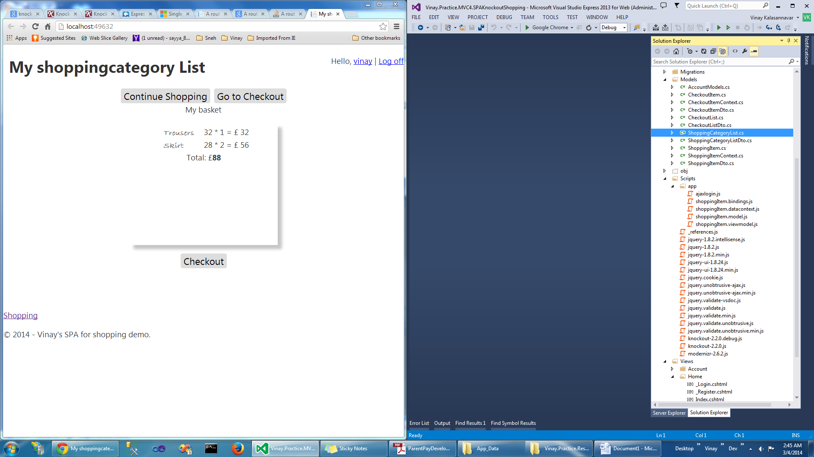

Fig 7: 